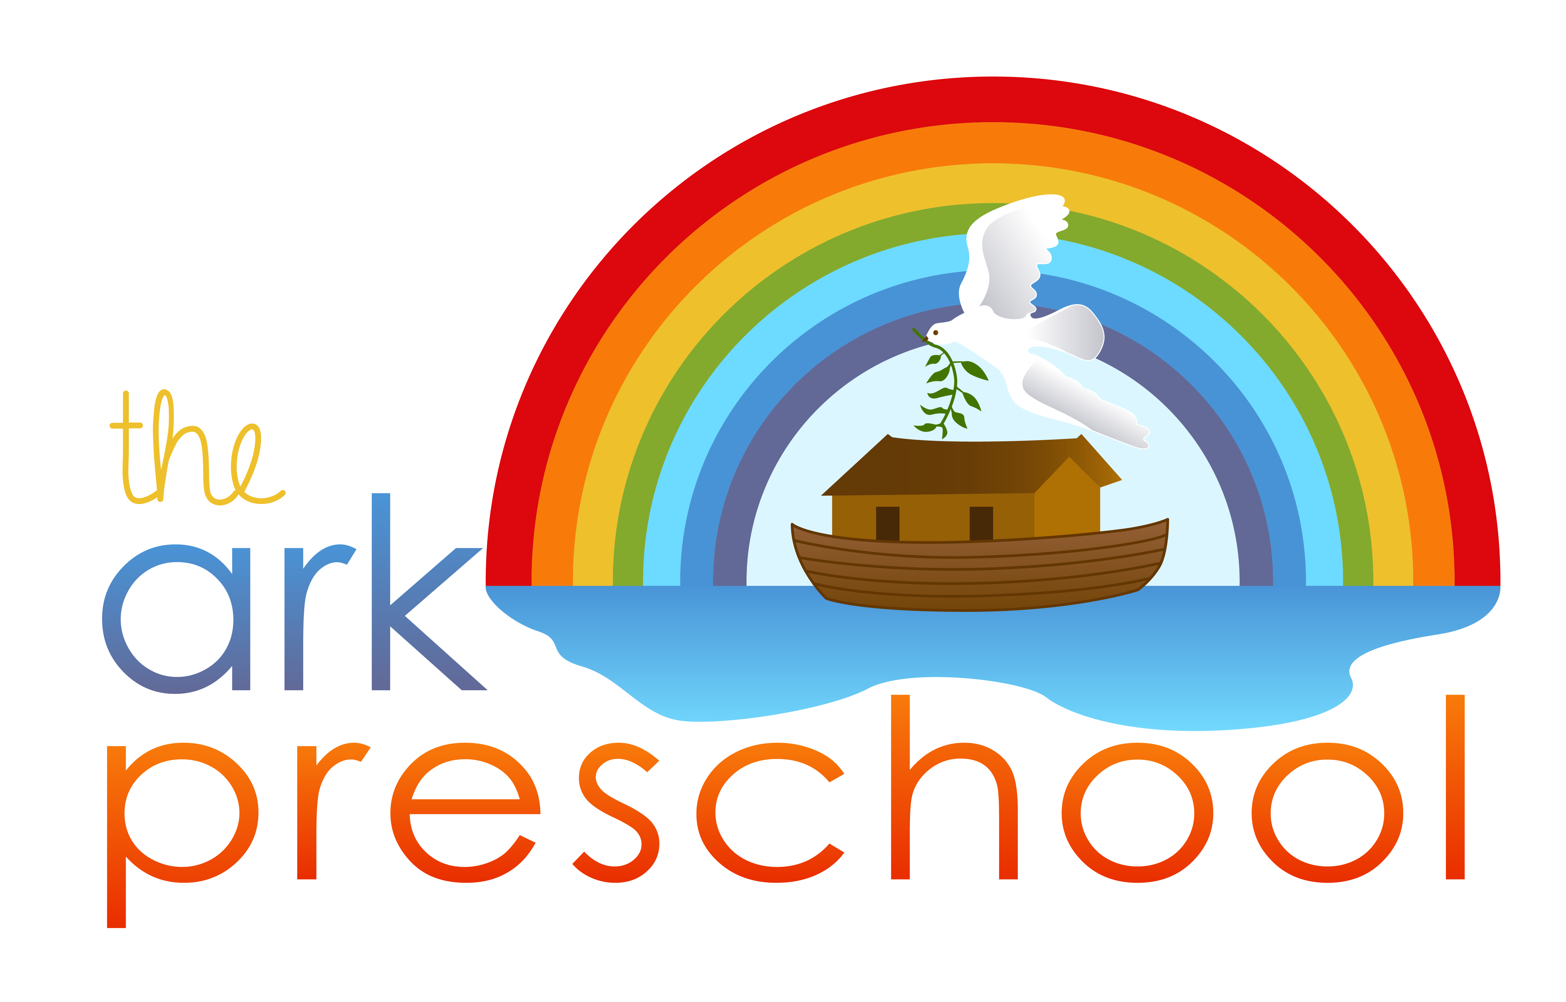

2024--2025 Enrollment Form

Please fill out this form and mark your class preference, then return the form to the preschool with your enrollment fee of $25.00 to reserve a place for your child.

Preschool Classes –
Morning Class, 3-4 years old (8:30-11:00) –
- Tuesday/Thursday - Tuition $80/month
Afternoon Class, 4-5 years old (12:30-3:00)
- Tues/Wed/Thurs - Tuition $90/month

Child's Name

Birthday

Parents' Names

Address

Telephone

Email

Parent Signature Date

Clay Center Covenant Church
1330 15th Street – Clay Center, KS 67432 785-632-5653

Facility Signature Date received

2024--2025 Enrollment Form

Please fill out this form and mark your class preference, then return the form to the preschool with your enrollment fee of $25.00 to reserve a place for your child.

Preschool Classes
Morning Class, 3-4 years old (8:30-11:00)
- Tuesday/Thursday - Tuition $80/month
Afternoon Class, 4-5 years old (12:30-3:00)
- Tues/Wed/Thurs - Tuition $90/month

Child's Name

Birthday

Parents' Names

Address

Telephone

Email

Parent Signature Date

Clay Center Covenant Church
1330 15th Street – Clay Center, KS 67432 785-632-5653

Facility Signature Date received

2024-2025 Re-Enrollment Form

Please fill out this form and mark your class preference, then return the form to the preschool to reserve a place for your child.

Preschool Classes – Jamie Reed, teacher

Afternoon Class, 4-5 years old (12:30-3:00)
- Tues/Wed/Thurs - Tuition $90/month

Child's Name

Birthday

Parents' Names

Address

Telephone

Email

Parent Signature Date

Clay Center Covenant Church
1330 15th Street – Clay Center, KS 67432 785-632-5653

Facility Signature Date received

2024--2025 Re-Enrollment Form

Please fill out this form and mark your class preference, then return the form to the preschool to reserve a place for your child.

Preschool Classes – Jamie Reed, teacher

Afternoon Class, 4-5 years old (12:30-3:00)
- Tues/Wed/Thurs - Tuition $90/month

Child's Name

Birthday

Parents' Names

Address

Telephone

Email

Parent Signature Date

Clay Center Covenant Church
1330 15th Street – Clay Center, KS 67432 785-632-5653

Facility Signature Date received

